OWASP Juice Shop:
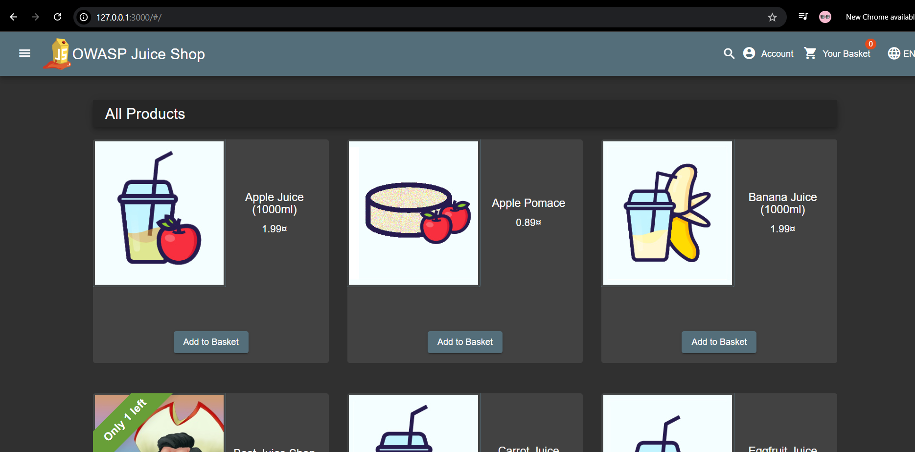

Lab Creation Guide:

Main goal:
The primary objective is to study the OWASP Juice Shop in order to discover typical issues with online security.
System I utilized:
- Windows 11 Home
- Docker
- Google Chrome (Web browser)
Setup to open OWASP in my Google chrome:
I utilized Docker on my personal machine to run OWASP Juice Shop. I accessed using Google Chrome to open it. My port is 3000.
Following are the screenshots of setup:
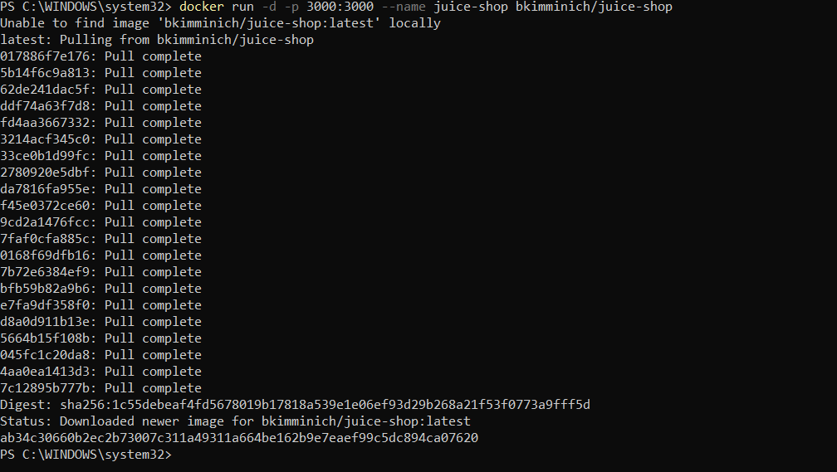
Docker Desktop:
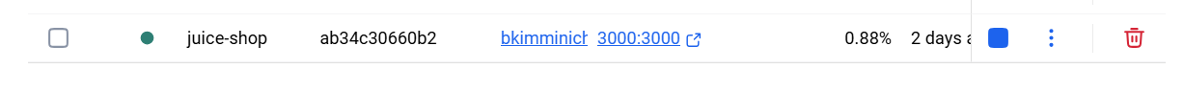
Link I used to get into the OWASP Juice Shop in the web browser: http://127.0.0.1:3000/#/

